RDS Multi-AZ Deployment Overview

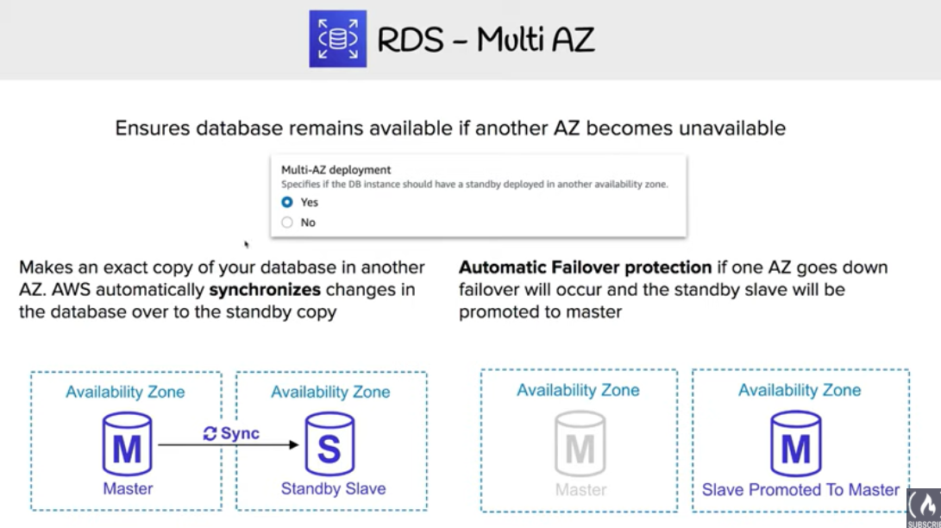

* Multi-AZ deployments provides high availability and automatic failover support for DB instances
* Multi-AZ helps improve the durability and availability of a critical system, enhancing availability during planned system maintenance, DB instance failure and Availability Zone disruption.
* **Multi-AZ is a High Availability feature is not a scaling solution for read-only scenarios; standby replica can’t be used to serve read traffic. To service read-only traffic, use a Read Replica.**
* **Multi-AZ deployments for Oracle, PostgreSQL, MySQL, and MariaDB DB instances use Amazon technology, while SQL Server DB instances use SQL Server Mirroring.**
* In a Multi-AZ deployment,
  + RDS automatically provisions and maintains a **synchronous standby replica in a different Availability Zone**.
  + Copies of data are stored in different Availability Zones for greater levels of data durability.
  + Primary DB instance is **synchronously replicated** across Availability Zones to a standby replica to provide
    - data redundancy,
    - eliminate I/O freezes during snapshots and backups
    - and minimize latency spikes during system backups.
  + DB instances may have increased write and commit latency compared to a Single AZ deployment, due to the synchronous data replication
  + Transaction success is returned only if the commit is successful both on the primary and the standby DB
  + There might be a change in latency if the deployment fails over to the standby replica, although AWS is engineered with low-latency network connectivity between Availability Zones.
* **When using the BYOL licensing model, a license for both the primary instance and the standby replica is required**
* **For production workloads, it is recommended to use Multi-AZ deployment with Provisioned IOPS and DB instance classes (m1.large and larger), optimized for Provisioned IOPS for fast, consistent performance.**
* When Single-AZ deployment is modified to a Multi-AZ deployment (for engines other than SQL Server or Amazon Aurora)
  + RDS takes a snapshot of the primary DB instance from the deployment and restores the snapshot into another Availability Zone.
  + RDS then sets up synchronous replication between the primary DB instance and the new instance.
  + This avoids downtime when conversion from Single AZ to Multi-AZ

## RDS Multi-AZ Failover Process

* In the event of a planned or unplanned outage of the DB instance,
  + RDS automatically switches to a standby replica in another AZ, if enabled for Multi-AZ.
  + Time it takes for the failover to complete depends on the database activity and other conditions at the time the primary DB instance became unavailable.
  + Failover times are typically 60-120 secs. However, large transactions or a lengthy recovery process can increase failover time.
  + **Failover mechanism automatically changes the DNS record of the DB instance to point to the standby DB instance.**
  + Multi-AZ switch is seamless to the applications as there is no change in the endpoint URLs but just needs to re-establish any existing connections to the DB instance.
* RDS handles failover automatically so that database operations can be resumed as quickly as possible without administrative intervention.
* Primary DB instance switches over automatically to the standby replica if any of the following conditions occur:
  + An Availability Zone outage
  + Primary DB instance fails
  + DB instance’s server type is changed
  + Operating system of the DB instance is undergoing software patching
  + A manual failover of the DB instance was initiated using **Reboot with failover**(also referred to as **Forced Failover**)
* If the Multi-AZ DB instance has failed over, can be determined by
  + DB event subscriptions can be setup to notify you via email or SMS that a failover has been initiated.
  + DB events can be viewed via the Amazon RDS console or APIs.
  + Current state of your Multi-AZ deployment can be viewed via the RDS console and APIs.
  + 